**Login Page and Onboarding Process – Sign Up New User - Admin**

Datamond Kevin - 0250303

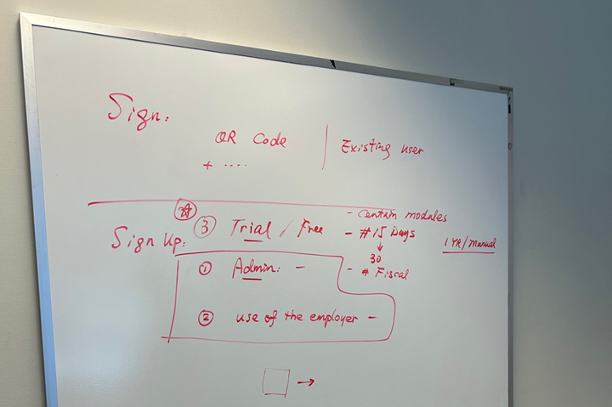

**SUPER ADMIN or OWNER Sign Up**

**New User Login – Company Profile Setup**

System will support **businesses across Canada**, including **Federal corporations and all provincial/territorial entities**. Below is a comprehensive breakdown of the **company information fields and mandatory messages** for each jurisdiction.

**Choose Federal or Provincial Incorporation**

Is your company incorporated Federally or Provincially?" *(From Last page, Welcome Page)*

* + Option 1: Federal Corporation
  + Option 2: Provincial/Territorial Corporation

**COMPANY**

Based on Selection, Show Corresponding Fields

**Option A:   
  
1) Federal Corporation (Canada-Wide)**

**Fields required:**

* **Legal Business Name**
* **Operating Name (if different from Legal Name)**
* **Business Type (Dropdown selection):**
  + Corporation (Federal / Provincial)
  + Sole Proprietorship
  + Partnership
  + Limited Liability Partnership (LLP)
  + Cooperative
  + Not-for-Profit Organization
  + Professional Corporation
* **Canada Business Corporation Number (CBN)**
* **Corporation Key *(For filings with Corporations Canada)***

**2) Provincial/Territorial Corporation**

* **Mandatory Message:**
  + Federal corporations must also register in the province/territory where they conduct business. Please ensure you have completed your provincial registration if required.
  + Dropdown: Select the province(s) where your business operates (to ensure compliance with local registrations).
* **Ontario Corporation Number (OCN) (Example: Ontario)**
  + Found in the Articles of Incorporation from Ontario Business Registry
* **Unique Company Key (For Ontario Business Registry access)**
  + Issued by the Ontario government to corporations for online filing & updates

**Provincial / Territorial Corporations**

Each province has unique registration requirements. Below is a breakdown:

| **Province/Territory** | **Corporation Number** | **Unique Company Key** | **Business Registry** | **Mandatory Message** |
| --- | --- | --- | --- | --- |
| **Ontario (ON)** | Ontario Corporation Number (OCN) | ✅ Yes (Required for Online Filings) | Ontario Business Registry | *"Ontario-incorporated businesses require an Ontario Business Identification Number (BIN)."* |
| **British Columbia (BC)** | BC Incorporation Number | ✅ Yes (BC Registry Key) | [BC Registries and Online Services](https://www.bcregistry.ca) | *"If your business collects PST in BC, please provide your PST number."* |
| **Alberta (AB)** | Alberta Corporate Access Number (CAN) | ❌ No | [Alberta Corporate Registry](https://www.servicealberta.ca) | *"Alberta-incorporated businesses must register for a Workers’ Compensation Board (WCB) account if they hire employees."* |
| **Quebec (QC)** | NEQ (Numéro d’entreprise du Québec) | ❌ No | Registraire des entreprises | *"Quebec businesses must register for a Revenu Québec tax number for GST/QST compliance."* |
| **Manitoba (MB)** | Manitoba Corporation Number | ✅ Yes (Manitoba Key) | Companies Office of Manitoba | *"Businesses in Manitoba must register for PST if selling taxable goods/services."* |
| **Saskatchewan (SK)** | Saskatchewan Corporate Registry Number | ❌ No | [Information Services Corporation (ISC)](https://www.isc.ca) | *"If you operate in Saskatchewan, you must register for PST if applicable."* |
| **Nova Scotia (NS)** | NS Registry Number | ❌ No | Nova Scotia Registry of Joint Stock Companies | *"All corporations in Nova Scotia must register with the Registry of Joint Stock Companies."* |
| **New Brunswick (NB)** | NB Business Number | ✅ Yes | [Service New Brunswick](https://www.snb.ca) | *"Ensure you have registered for the New Brunswick Corporate Registry and tax accounts as needed."* |
| **Newfoundland & Labrador (NL)** | NL Incorporation Number | ❌ No | Registry of Companies | *"All Newfoundland & Labrador businesses must register for the HST."* |
| **Prince Edward Island (PEI)** | PEI Business Registration Number | ❌ No | PEI Business/Corporate Registry | *"Ensure you are registered for any required provincial tax accounts."* |
| **Yukon (YT)** | Yukon Corporation Number | ❌ No | Yukon Corporate Affairs | *"Yukon-incorporated businesses must register for a Business Number (BN) with the CRA."* |
| **Northwest Territories (NT)** | NWT Business Number | ❌ No | NWT Corporate Registry | *"Corporations operating in the Northwest Territories must register with the GNWT."* |
| **Nunavut (NU)** | NU Business Number | ❌ No | Nunavut Corporate Registry | *"Ensure you comply with Nunavut’s corporate registry and taxation requirements."* |

**Option B:   
  
2) Provincial Corporation (ie Ontario)**

**1️. Company Information**

* **Legal Business Name** (As registered in Ontario)
* **Business Operating Name (if different from Legal Name)**
* **Business Type:** (Dropdown selection)
  + Corporation (Federal or Ontario)
  + Sole Proprietorship
  + Partnership
  + Not-for-Profit
  + Professional Corporation
* **Ontario Corporation Number (OCN)**
  + Found in the **Articles of Incorporation** from Ontario Business Registry
* **Business Identification Number (BIN)** (If registered with Ontario Business Registry)
* **Canada Revenue Agency (CRA) Business Number (BN)**
  + Used for tax filing, GST/HST, payroll, and corporate tax
* **Unique Company Key** (For Ontario Business Registry access)
  + Issued by the Ontario government to corporations for online filing & updates

**2. Industry & Business Activities**

* Industry Type (NAICS Code) (Dropdown selection based on North American Industry Classification System)
* Business Activity Description (Short text field)

**3. Financial & Tax Registration**

* Corporate Tax Account (T2 filing number)
* Do you sell taxable goods/services? (Yes/No)
  + If "Yes" → Requires HST/GST Registration Number
  + GST/HST Account Number (If applicable)
* Payroll Account Number (For businesses with employees)

**4. Business Address & Contact**

* Registered Office Address (As per incorporation documents)
* Mailing Address 1 (If different from registered office) (+Mailing Address 2)
* Company Phone Number & Email (Additional Phone & Email)
* Website (Optional)
* Primary Contact Name & Position (CEO, Director, etc.)

**5. HR & Organizational Hierarchy (For Medium & Enterprise Users or Assign to HR)**

* Users Roles (for Approval workflow, receiving Account Setup notification)

o Bookkeeper

o Accountant

o HR Manager

o Sales / Finance team

o Custom Role Creation

• Access & Permissions Settings (Role-Based Access Control)

**6. Accounting Firm Authorization**

* Authorize Outsourcing Accounting Firm (Drop Down List, or Search)

**Additional Features for Company Profile Setup Page**

* **Province Selection Dropdown** (Changes input fields dynamically based on provincial requirements)
* **Automated Business Number Lookup** (If user enters incorporation number, system can fetch details from federal/provincial registry APIs)
* **Pre-fill CRA Registration Forms** (For HST, Payroll, Corporate Tax)
* **Upload Incorporation Documents** (Optional for verification)